Python Lab: Azure Blob ML Workflow

Bipeen sinha
2026

Table of Contents
Objective 1
Scenario 1
Step-by-Step Instructions 1
Step 1 - Create Project Folder 1
Step 2 - Create Python Virtual Environment 2
Step 3 - Install Required Packages 2
Step 4 - Project Structure 3
Step 5 - Azure Setup 3
Step 6 — Login from Your Local Python Environment 7
Step 7— Create blob access function 9
Step 8 — Test Blob Access 12
Step 9 — Validate Raw Data 14
Step 10 — Create Feature Engineering Program 15
Step 11 — Train Model 16
Step 12 — Test Prediction 18

Objective
Build a local Python environment that connects to Azure Blob Storage for an end-to-end MLOps workflow:
- Upload raw billing data to Blob
- Validate and engineer features
- Train, predict, and retrain ML models

Scenario
You are a Vodafone data engineer tasked with detecting billing anomalies. Customer billing data is stored in Azure Blob Storage. Your workflow must:
- Access raw CSV data from Blob
- Validate and transform it into features
- Train a Decision Tree model
- Predict anomalies for new customers
- Retrain the model when new data arrives

Step-by-Step Instructions

Step 1 - Create Project Folder
mkdir FeatureStoreLab
cd FeatureStoreLab

Step 2 - Create Python Virtual Environment
py -m venv labenv
.\labenv\Scripts\Activate.ps1
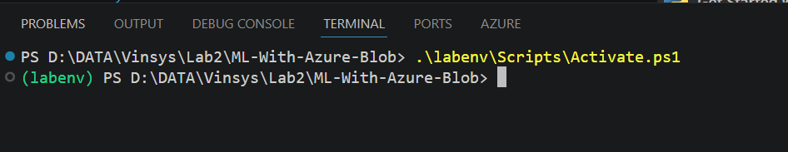

Step 3 - Install Required Packages
pip install pandas scikit-learn joblib azure-identity
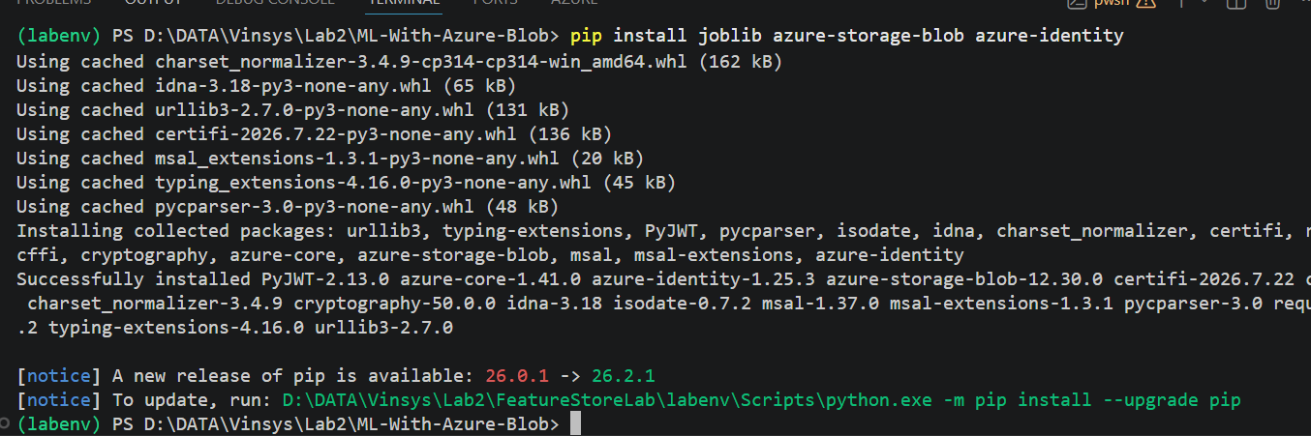

python -m pip install azure-storage-blob

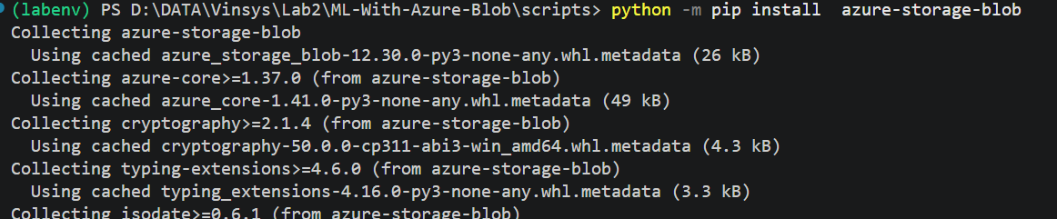

Step 4 - Project Structure
FeatureStoreLab
│
├── labenv
├── scripts
│ ├── blob_utils.py
│ ├── validate_data.py
│ ├── create_features.py
│ ├── train_model.py
│ ├── predict.py
│ └── retrain_model.py
└── models

Step 5 - Azure Setup
- Create Storage Account (e.g., vodafonemlstorage2026)

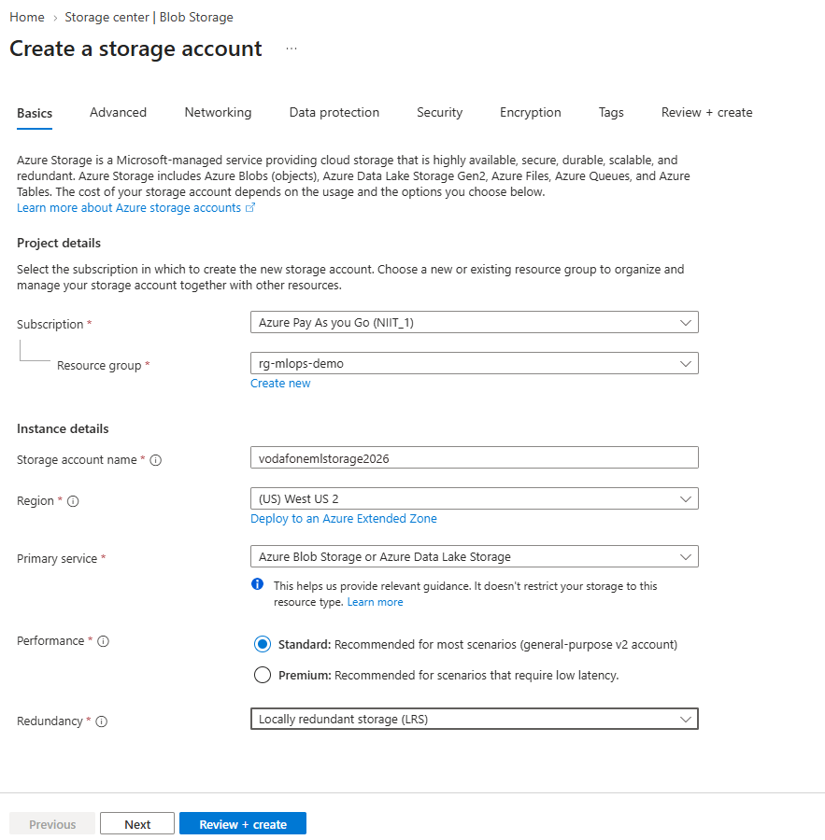

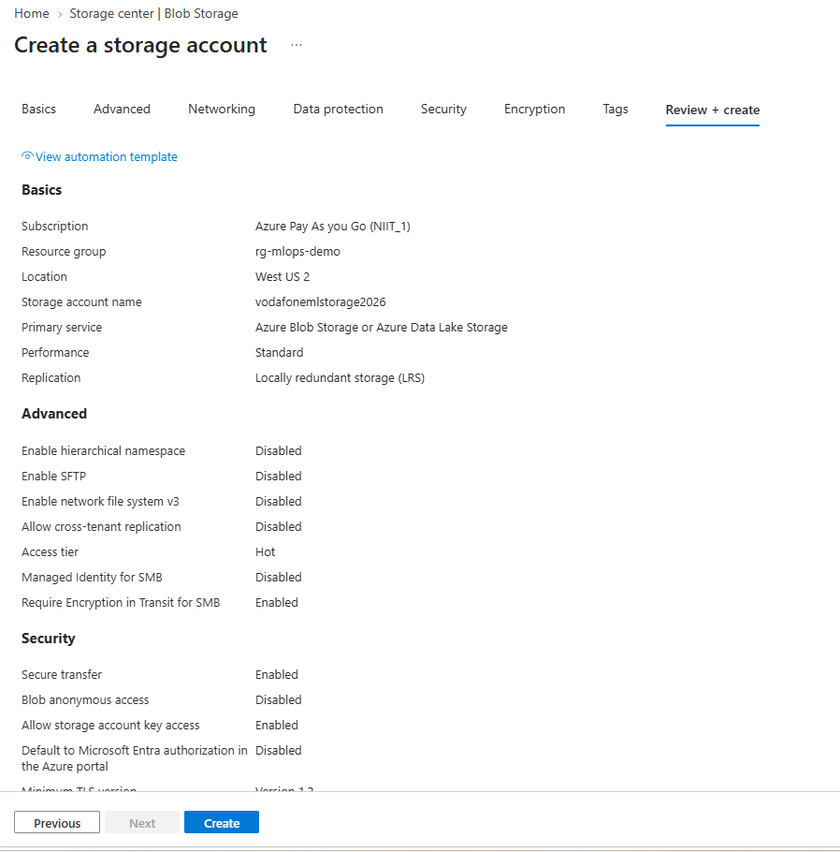
- Create Blob Container: mlops

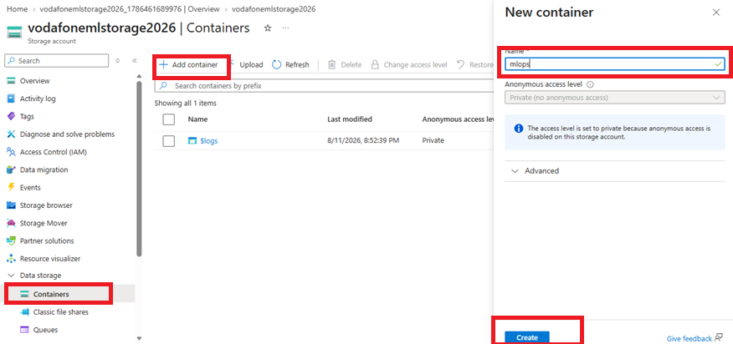
- Upload raw CSV: mlops/raw-data/billing_data.csv
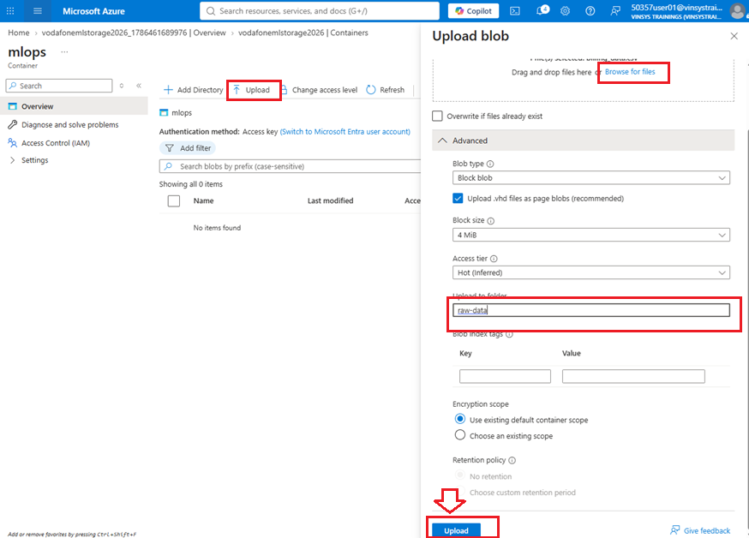

- Confirm upload
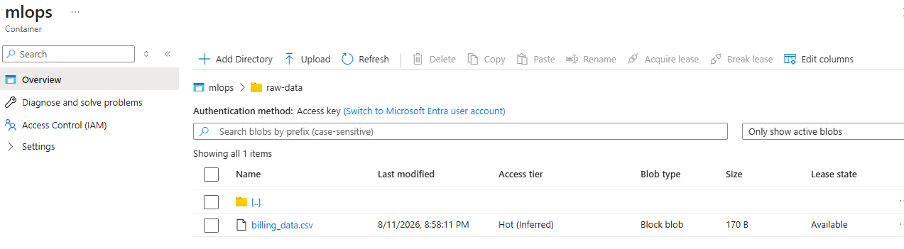

Step 6 — Login from Your Local Python Environment
Open VS Code terminal:
az login

A browser will open.

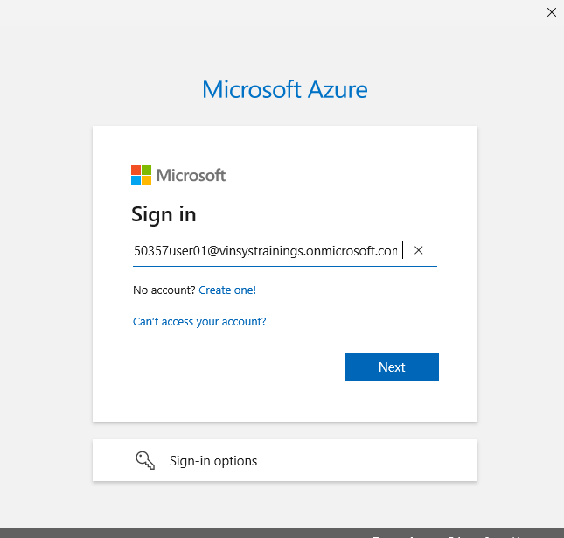
Complete the login.

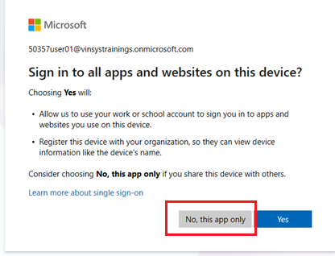
Verify:

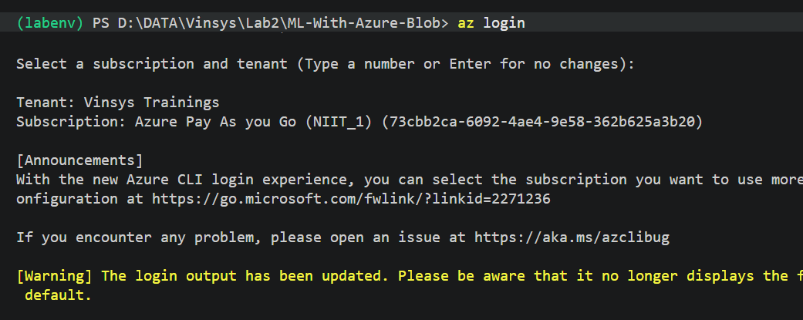
az account show

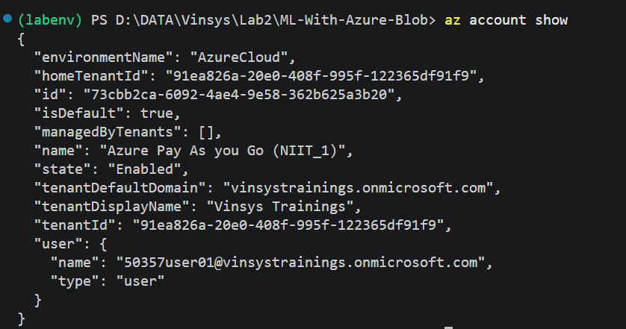
Our Python program will use:
DefaultAzureCredential()
This allows your local Python environment to use your Azure login.
So:
VS Code
↓
Python
↓
DefaultAzureCredential
↓
Azure
↓
Blob Storage

Step 7— Create blob access function
Create:
scripts/blob_utils.py
Use:

from azure.storage.blob import BlobServiceClient

# Azure Storage connection string
CONNECTION_STRING = "DefaultEndpointsProtocol=https;AccountName=vodafonemlstorage2026;AccountKey=Z29SNW0huVRf8sPSyD8d4ekswIrcMnCirC17HPBSacAdz+lUtL2Sr8NG/1EDDrjlGngknj2+nuA4+AStuTvtww==;EndpointSuffix=core.windows.net"

# Blob container
CONTAINER = "mlops"

# Connect to Azure Blob Storage
blob_service_client = BlobServiceClient.from_connection_string(
CONNECTION_STRING
)

def download_blob(blob_name, local_file):

blob_client = blob_service_client.get_blob_client(
container=CONTAINER,
blob=blob_name
)

with open(local_file, "wb") as file:
data = blob_client.download_blob()
file.write(data.readall())

print(f"Downloaded: {blob_name}")

def upload_blob(local_file, blob_name):

blob_client = blob_service_client.get_blob_client(
container=CONTAINER,
blob=blob_name
)

with open(local_file, "rb") as file:
blob_client.upload_blob(
file,
overwrite=True
)

print(f"Uploaded: {blob_name}")
Change:
CONNECTION_STRING = "YOUR_STORAGE_ACCOUNT_NAME"
to your actual Storage Account connection string

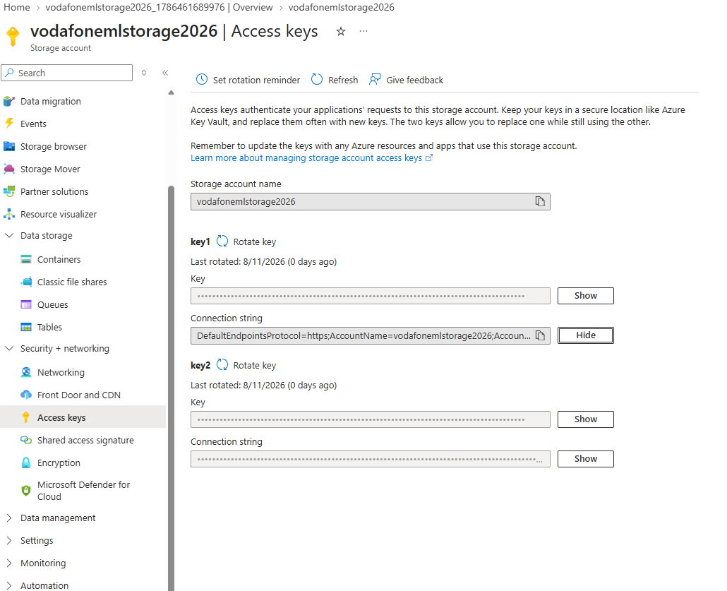
For example:
STORAGE_ACCOUNT = "vodafonemlstorage2026"

Now run it
Py blob_utils.py

Step 8 — Test Blob Access
Before doing ML, let's test the connection.
Create:
scripts/test_blob.py
from blob_utils import download_blob

print("Testing Azure Blob Storage...")

download_blob(
"raw-data/billing_data.csv",
"billing_data.csv"
)

print("Blob access successful!")

Run:
cd scripts
py test_blob.py
Expected:
Testing Azure Blob Storage...

Downloaded: raw-data/billing_data.csv

Blob access successful!
You should now see a temporary local file:
scripts
│
├── billing_data.csv ← downloaded from Blob
├── blob_utils.py
└── test_blob.py

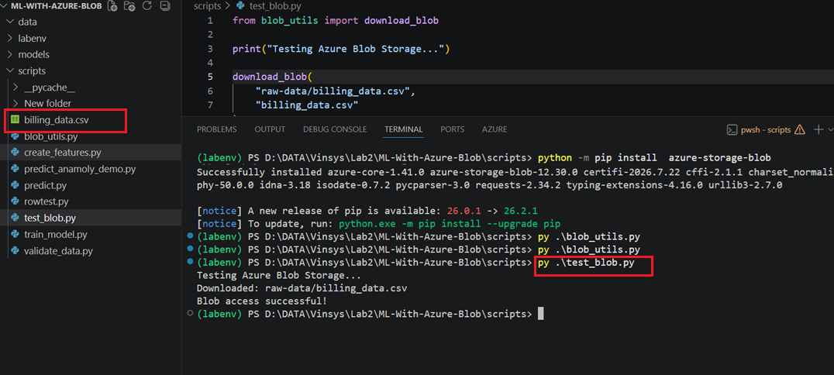

Step 9 — Validate Raw Data
Now create:
scripts/validate_data.py

import pandas as pd
from blob_utils import download_blob

print("=== TEST RT-001 - Validate Raw Data ===")

download_blob("raw-data/billing_data.csv", "billing_data.csv")
df = pd.read_csv("billing_data.csv")

required_columns = ["CustomerID","DataGB","Calls","BillAmount"]
missing_columns = [c for c in required_columns if c not in df.columns]

if missing_columns:
print("FAIL - Missing columns:", missing_columns)
else:
print("PASS - Required columns exist")

if df[required_columns].isnull().sum().sum() == 0:
print("PASS - No missing values")
else:
print("FAIL - Missing values found")

if df["CustomerID"].duplicated().sum() == 0:
print("PASS - No duplicate CustomerID")
else:
print("FAIL - Duplicate CustomerID found")

Run:
python validate_data.py

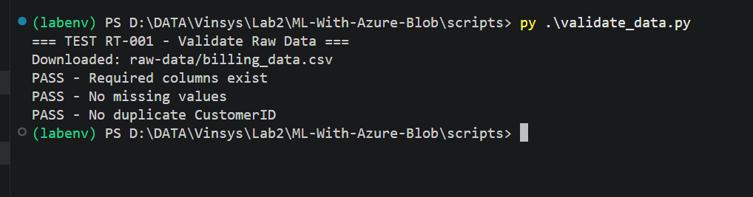

Step 10 — Create Feature Engineering Program
Now create
create_features.py.

Run:
python create_features.py

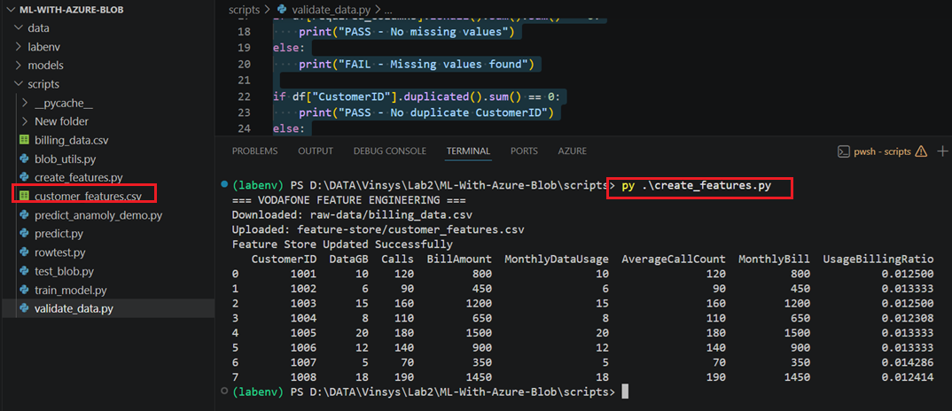
Now Blob Storage contains:
mlops
│
├── raw-data
│ └── billing_data.csv
│
└── feature-store
└── customer_features.csv

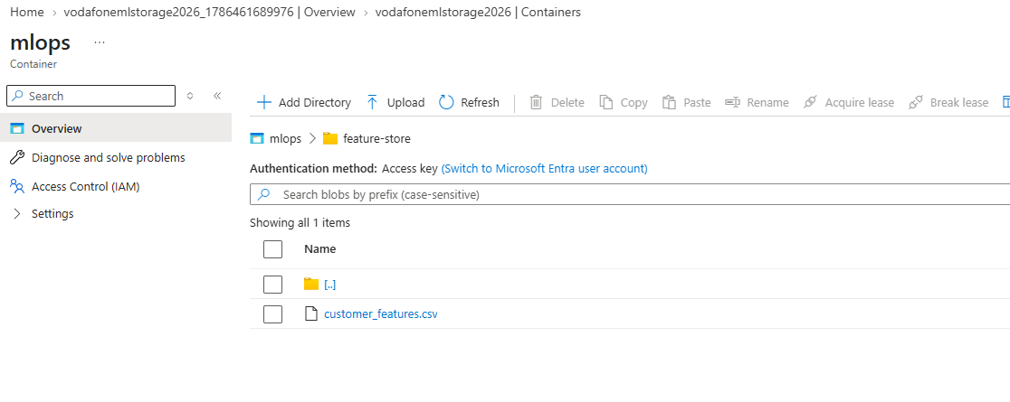

Step 11 — Train Model
Create/update:
scripts/train_model.py

import pandas as pd, joblib
from sklearn.tree import DecisionTreeClassifier
from blob_utils import download_blob

print("=== VODAFONE MODEL TRAINING ===")

download_blob("feature-store/customer_features.csv", "customer_features.csv")
df = pd.read_csv("customer_features.csv")

df["BillingStatus"] = [0,0,1,0,1,0,0,1] # Labels

X = df[["MonthlyDataUsage","AverageCallCount","MonthlyBill","UsageBillingRatio"]]
y = df["BillingStatus"]

model = DecisionTreeClassifier(random_state=42)
model.fit(X, y)

joblib.dump(model, "../models/model_v1.pkl")
print("AI Model Trained Successfully")

Run:
python train_model.py

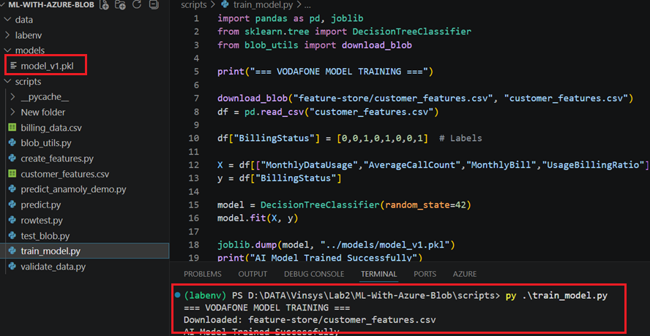

Step 12 — Test Prediction
Create:
scripts/predict.py

import pandas as pd, joblib

print("=== VODAFONE BILLING PREDICTION ===")

model = joblib.load("../models/model_v1.pkl")

new_customer = pd.DataFrame({
"MonthlyDataUsage":[12],
"AverageCallCount":[130],
"MonthlyBill":[900],
"UsageBillingRatio":[0.013]
})

prediction = model.predict(new_customer)

print("Prediction :", "Normal Billing" if prediction[0]==0 else "Billing Anomaly Detected")

Run:
python predict.py

